Vital categories to include | Examples: | Mon | Tues | Wed | Thurs | Fri | Sat | Sun
Cardio:  - 30-60 min  - 3-5x/week  - Moderate intensity exercise | 
 | 
Strength  - 2-3x/week  - 10-15 reps per set  - 2-3 sets | 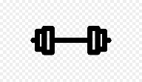
Flexibility:  - 10 min/day at the end of exercise  - 10-30 seconds per stretch | 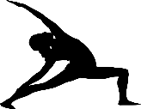
Balance:  - 20-30 min  - 3x/week | 
Balance:  - 20-30 min  - 3x/week | 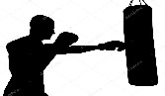
Balance:  - 20-30 min  - 3x/week | 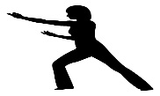
Balance:  - 20-30 min  - 3x/week | 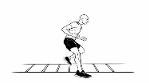
Balance:  - 20-30 min  - 3x/week | 
PWR! Moves
- Daily. Move Big!
- 10x or each movement

Types of Exercise |  | Details
 | Walking  or  Running | Walking can be on a treadmill or over ground. You can try walking fast and slow speeds as an extra challenge. Benefits have been shown for the use of trekking poles over ground.
 | Cycling | Cycling can be done on stationary or road bike. The benefits of cycling occur with a fast spin rate of >85 RPM  Again, try going as fast as you can for intervals during your exercise as an added challenge.
 | Weight Lifting | Strengthening should be done 2-3x/week. 10 – 15 reps/sec with 2-3 sets. Focus on the extensor (straightening) muscles like the upper back.
 | Yoga | Yoga can be done standing or seated. If yoga includes standing poses, it can address balance deficits or be considered strengthening. Look for a PD specific yoga class near you, or try one off youtube or your free cable “on demand” to practice at home.
 | Dance | Numerous types of dance have been found beneficial including waltz and tango. Depending on the intensity of the dancing, this could also be considered cardio.
 | Boxing | Non-Contact boxing can be done in both sitting or standing. This can include upper body and lower body coordination and agility exercises. Depending on the intensity of boxing, this could also be considered cardio
 | Tai Chi | Tai Chi or Qi Gong can be beneficial and is offered in standing and seated forms
 | Agility | Agility exercises consist of a mix multi-directional movement, coordination exercises and incorporates doing 2 things at once. Examples: ladder drills, lunges, hurdles, jumping, jumping rope. It’s ok to start by holding on to something when you first begin.
 | Ball Sports | Ball sports include basketball, tennis, ping pong and pickleball. Depending on the intensity, this could also be considered cardio.
 | PWR! Moves | PWR! moves can be performed laying on your back, on all 4’s, in sitting, and in standing. You can perform each move individually or put them together in FLOW. Use www.youtube.com and search “PWR! moves positions” for reminders of the evidence based movements for PWP.

